Week 10 : Client and Program Evaluation

JP Fuenzalida Lorca,
MS SPP, University of Western States
COUN 6120: Research and Design Methods
Thomas Dooley, LPC, CRC

March 21st 2023, Winter 2023

Introduction
Client and program evaluation became an almost mandatory part of any professional guild in most fields of activity. Developing a model, standards and other measures to understand on one side the client’s nature and characteristics, and on the other the quality of the provided service by that very same client requires to investigate in the most ethical way on how to collect, what to collect and for which purpose (ACA, 2014 ; Murphy et al., 2018). The limits of a practitioners ability to and competence to evaluate are the first consideration to keep in mind : Using tests requires to be trained to use, score and provide a meaningful interpretation of the tests and results, and so is it for each possible data collected (ACA, 2014 ; Murphy et al., 2018). A noble purpose isn’t sufficient to establish either a testing method or a satisfactory questionnaire; client’s welfare is the key element to bear in mind, as well as peers and clinicians under our supervision (ACA, 2014).
In this case study, the collection of data allowed us to understand what our field of practice is, or in other words, what population, type of disorders, income level and other socio-demographics are our “everydays” at the practitioner’s office. The collection of client symptoms and their acuity through three different tests (PHQ-9 for depression, GAD-7 for anxiety and SWLS for satisfaction of life) are elements that, once cross-referenced with the demographics could provide leads and insights regarding the contextual characteristics of our clients population and what services we provide. Finally, the program’s feedback requested from our clients, in this case a Client Satisfactory Questionnaire (CSQ-8) is the last element of this informational flow by highlighting and measuring if our mental health services are aligned and provide the best possible service to our specific population and if not, what changes could be envisioned (Murphy et al., 2018 ; Vasquez et al., 2019).
Program’s insights – key focus and interventions
Based on the 25 individuals forming our client’s population, 56% are females, 36% males and 8% non-binary. The youngest patient is 16 years old while our oldest is 71, and both average and median ages are within the same range, with 34.3 years old for the average and 31 years old for the median. Regarding further demographics, 46% of our clients are married, 48% of them have an income between $50.000 to $100.000 USD, with a lower and top quintile (<25.000 / >100.000) at 20% and 16%.
Regarding Ethnicity, 60% of our clients are Caucasian, 12 % Latinx and the remaining 28% almost equally split between American Indian, Alaskan Native, African American, Native Hawaiian or Other Pacific Island and Asian (4%) ; this split naturally leads to consider the need for a multicultural training of our clinicians, having to respond to not only 4 out of 10 times to different ethnicity, but as well considering a modern perspective and definition of cultural awareness as combined more than half of our clients are females and non-binary (Murphy et al., 2018 ; Allen, 2007 ; Keum et al., 2021). Based on that insight, the need to evaluate current multicultural sensitivity and humility our clinician’s work needed to be investigated and therefore a measure of “multicultural sensitivity satisfaction” was created in order to understand how each of our practitioners responds to those populations (chart 1).
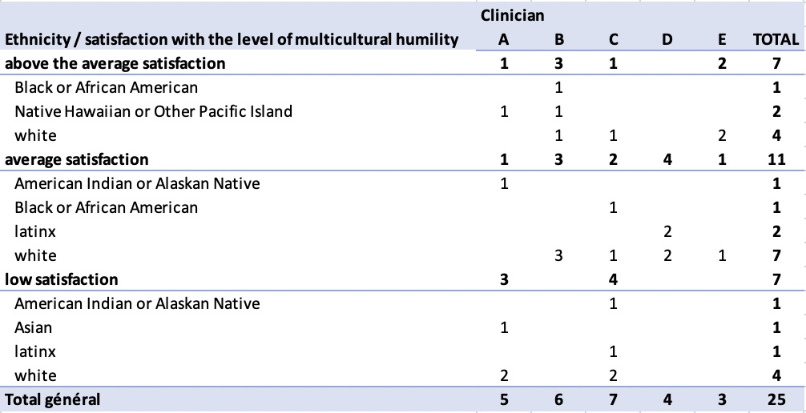

chart 1 : # of Clients Satisfaction with the level of multicultural humilty by ethnicity and clinician.

As we can see, African American and Latinx populations are relatively satisfied with the multicultural considerations shown by the clinician, American Indian / Alaskan Natives already feeling at an average if not having a low satisfaction regarding the same topic. The possibility for improvement comes with the Asian and White population showing average to low satisfaction levels, and especially when it comes to female and non-binary patients (Chart 2).
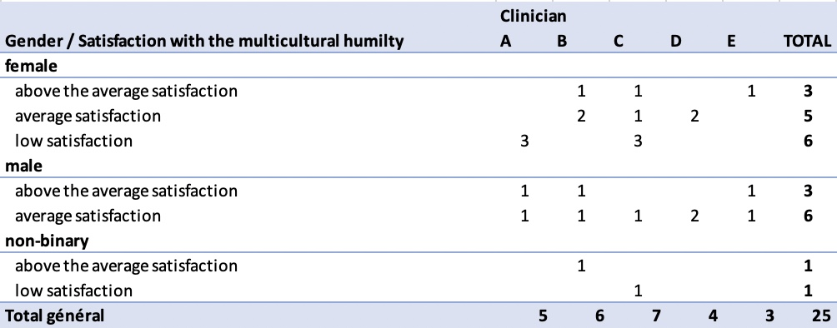

chart 2 : # of Clients Satisfaction with the level of multicultural humilty by gender and clinician.

Regarding the details per Clinician, A and C are the ones providing more of those negative feedbacks and establishing a plan or a supervision must be envisioned and would be beneficial to the entire program (Chart 1 & 3). Indeed we need to consider that both of our clinician represent 48% of the intake which could explain the higher probability for having a larger variety of feedbacks, but it shows as well that they might be in need for investigating their inner biases and open to a humble outreach when it comes to validating the differences (Miller, TaeHyuk Keum, Thai, Lu, Truong, Huh, Li, Yeung, & HaRim Ahn, 2018 ; Keum et al., 2021).
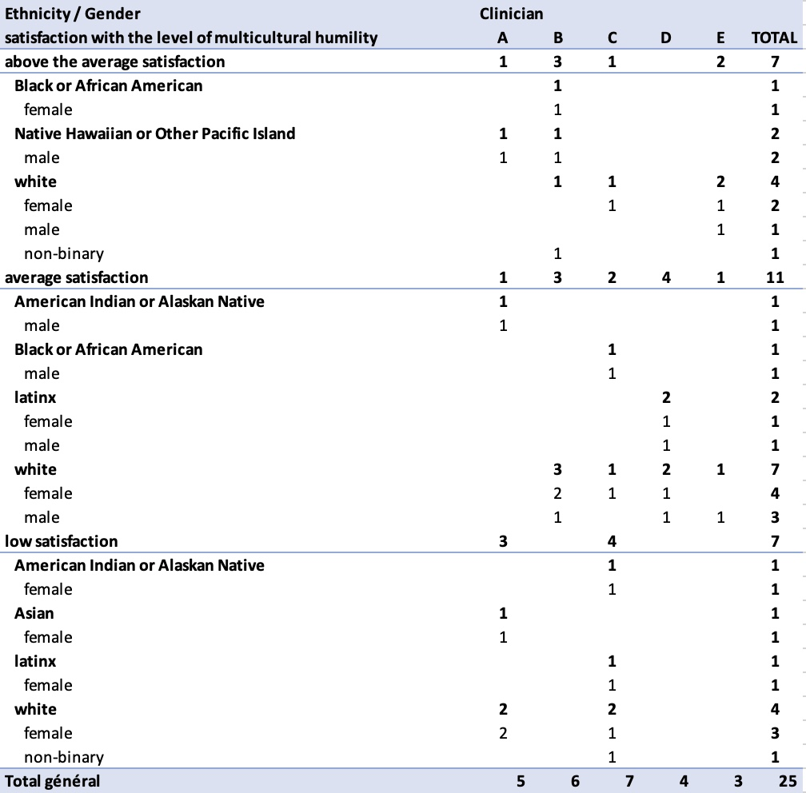

chart 3 : # of Clients Satisfaction with the level of multicultural humilty by ethnicity /gender and clinician.
These consideration regarding a possible improvement in the multicultural training of the clinicians does not mean a lack of trust or satisfaction form our clients in the program. Indeed , CSQ-8 results provide a combined average and high satisfaction levels of 84% (48% for high satisfaction), which is a great sign that our services are helping and well designed in general.
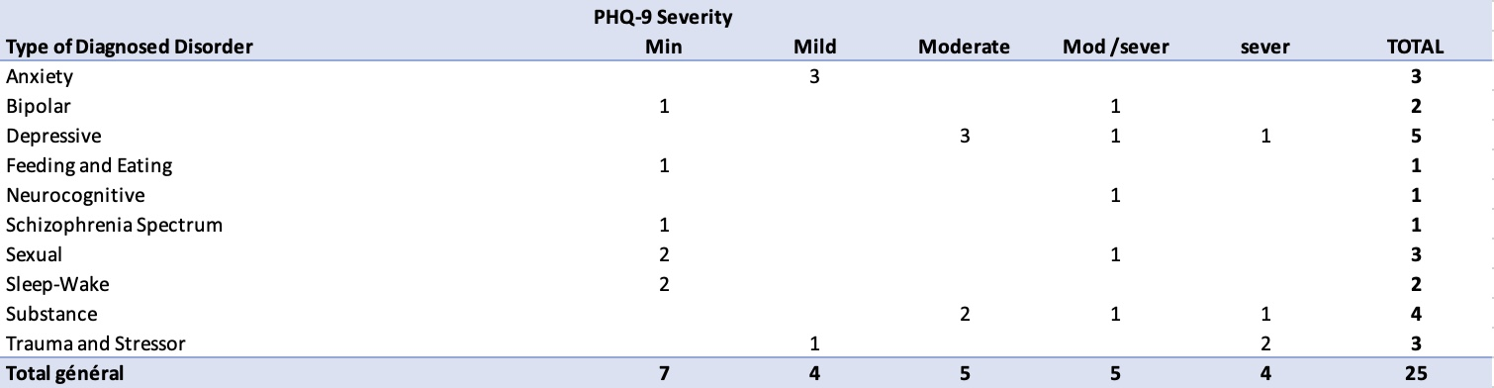
On the primary diagnostic and type of disorders that bring our clients to our services, Depressive (20%) and Substance (16%) are in the lead, followed by Trauma, Anxiety and Sexual (12%), Bi-polar and Sleepwake (8%) and finally Neurocognitive, Feeding and Eating and Schiozophrenia (4%). Regarding Depressive symptoms (PHQ-9 test), 16 out of 25 patients show Mild to Moderate symptoms ; on the anxiety spectrum (GAD-7 test), the same pattern with 16 out of 25 patients in the Minimal to Moderate anxiety levels shows the close correlation between both mental states and asks the question of the added value of using both tests (Chart 4 & 5). Choosing to test depressive and anxiety levels , while they often are concurrent and associated has been proven to provide a benefit regarding the consideration of severity and number of distressing symptoms, providing the appropriate treatment (especially when using a “Number Needed to Identify” – NNI – metric) and reducing drop outs (Newman, 2022).

chart 4 : Severity of depressive symptoms by type of diagnosed disorder
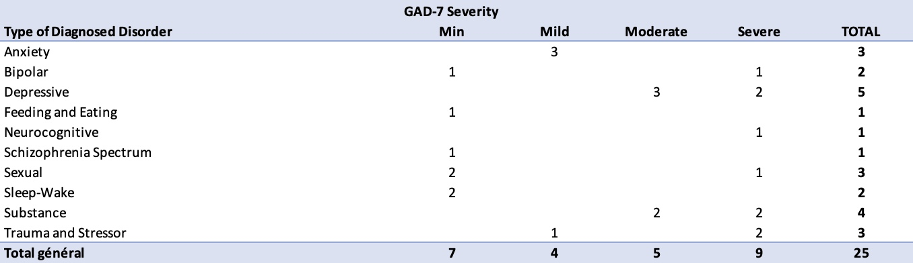

chart 5 : Severity of anxiety symptoms by type of diagnosed disorder
As a contrast to previous depressive and anxiety symptoms perspective, the Satisfaction with Life Scale provides an indication an individual’s subjective notion of well-being. We find here a different pattern with the lower and the top quintile leading the results with 8 out of 25 on the extremely satisfied side of life versus 9 out of 25 on the very dissatisfied of life (chart 6).
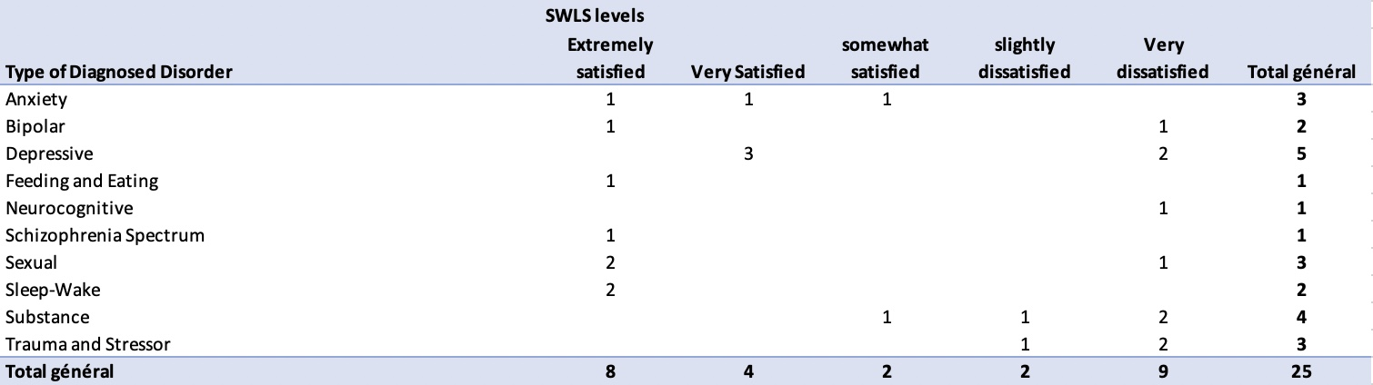

chart 6 : Satisfaction with life levels by type of diagnosed disorder
The SWLS measurement has been proven to be consistence, reliable and valid, but however shows its own limitations and appears to be insensitive at high levels of life satisfaction and therefore should be used to understand the dynamic and as an evaluation of changes of a individual (Schutte et al., 2021). With that in mind, it is needed to explain the patients and clients the purpose of this test in order to provide the logical perspective to be used when talking about the results. For instance here we could evaluate that the levels of distress of the Depressive population in treatment is improving as they show higher levels of satisfaction (than what could have been the results in the past).
Finally, our clients have already achieved on average 9.72 sessions (1 minimum, 22 maximum) and expect to complete an extra number of sessions of an average of 19.36, with a median of 24. In other words, it takes 30 sessions for our patients to either show improvement or to drop out with little satisfaction. Recent studies postulate that 15 to 20 sessions are required for 50% of the patients to recover (APA, 2017). This means our program provides longer term treatment in order to achieve more complete symptom remission (APA, 2017) ; however when considering the previous SWLS, we might be tempted to offer new approaches with shorter therapies like Online solution-focused brief therapy when it comes to anxiety issues (Novella et al., 2022) and make our service more accessible to most, while at the same time using modern technologies to upgrade our program and match our younger clients habits, 52% of our clients being below 30 years old.
As we see, the focus over 3 or 4 key points already provides possibilities for improving the quality of our services, the skills of our clinicians and to proceed to a possible upgrade of our program. The result of gathering all these insights through qualitative or quantitative methods is to make sure we offer the best possible service to our clients as any improvement made puts us closer to the ethical guidelines of our profession (ACA, 2014 ; Murphy et al., 2018) and allows us to create a durable and strong therapeutic alliance with our patients, as the most important is to provide a just , honest, humble and benevolent service to every of them.

Program Evaluation Measure
Evaluating a program and gathering clients or patients feedback is a modern tool that no practitioner or program can delay in establishing within their practice. Indeed if on one side the protection of the consumer, the requirements of insurances plans and the administrative requirements ask for validation of quality services, the value of collecting all the satisfaction related information provides the consumer’s viewpoint that allows to assess intervention programs, quality of services and eventually leads to the needed changes that programs or clinicians would not be able to spot by themselves (Sabourin et al., 1989 ; Murphy et al., 2018 ; Vasquez et al., 2019). Established and proven researched methodologies exist when it comes to Program evaluation and establishing the efficacy and value of a clinical intervention or of its innovations has been researched in many different ways with different models and logics (Murphy et al., 2018).
For this assignment, the use of the Client Satisfaction Questionnaire -8 (CSQ-8) has been chosen. Indeed, documentation and proofs of its efficiency, reliability and reported successful use has been documented since the 1980’s and its creation by Attkison and its colleagues (Sabourin et al., 1989 ; Murphy et al., 2018). This questionnaire, composed of 8 questions covers the essential of cross referenced information regarding satisfactory results and are general enough to embrace a wider stance of that very same information (Sabourin et al., 1989 ; Murphy et al., 2018). Associated to demographic information, those 8 questions become source of extended knowledge for any clinician, practitioner or program in understanding where a clients satisfaction might lie. Finally, the proven efficiency in a multicultural environment of the CSQ-8 through its kept validity when translated in different languages makes it a ready made tool to start with (Sabourin et al., 1989 ; Murphy et al., 2018 ; Vasquez et al., 2019). Practically, 8 questions are being asked and scores from 1 (the lowest) to 4 (the maximum) are being answered, creating a scale from 8 to 32 , the lower the score, the lower the satisfaction (8-16 low / 16-24 average / 24-32 high).
Questions :
Questions CSQ-8
Client Satisfaction Questionnaire -8
1. Quality of service?
2. Kind of service you wanted?
3. Extent program met your needs?
4. Recommend program to friend?
5. Satisfaction with the amount of help received?
6. Services helped you to deal with problems?
7. Overall satisfaction with the service?
8. Return to program for help?

Session Outcome Instrument
The session outcome Instrument that was chosen here narrows its focus around the notions of multicultural competency from the clinicians. Indeed in current reality of major demographic changes and international exchanges with population moving across continents and latitudes (Allen, 2007 ; Keum et al., 2021), client’s perception of the clinician’s attractiveness and credibility is a major element that can enable or prevent success in therapy. We are all products of our cultural conditioning and inherit the biases of the larger society and of our life experiences and education (Sue, Sue, Neville & Smith, 2019). That implies that everything we have experienced and learned, that our cognitive, emotional and behavioral reactions, interactions, expectations and therefore adaptive habits and mechanisms never happened in a vacuum and always have a multilayered structure with a micro, a meso and a macro component, where the different internal and external locus of control and responsibility varies from individual to individual, promoting a different grasp on events, ideas, facts, emotions and perceived knowledge. Ways of living are deeply infused into all cognitive, emotional and behavioral apprehension of the world, and bringing the possibility of multidimensional complexity into a program and sensitize the clinicians to their duty to be culturally humble requires to work a lot in preventing, training and preparing each stakeholder to the idea of embracing diversity and making justice to it and validating every experience (ACA, 2014). Key elements such as psychoeducation, validation, self-awareness, critical consciousness, critical examination of privilege and racial attitudes, culturally responsive social support, showing a positive identity, externalize/minimize self-blame and outreach doubled with advocacy in a humble mutual understanding are tools and an education that needs to be promoted by the clincian and passed over to the patients (Miller, TaeHyuk Keum, Thai, Lu, Truong, Huh, Li, Yeung, & HaRim Ahn, 2018).
In that context, the measure has been a simple question with 4 degrees of possible rating. The quantitative feedback can be doubled with a qualititative one if the patient wants by detailing the why of the score
Question and Scale :
Scale
0 = no statisfaction
1= low satisfation
2 = average satisfaction
3 = above the average satisfaction
4= extreme satisfaction
- Did the Clinician meet your expectations and show interest and respect to your personal experiences and cultural background ?

References

Allen, J. (2007). A Multicultural Assessment Supervision Model to Guide Research and Practice, Professional Psychology: Research and Practice, 2007, Vol. 38, No. 3, p248 –258

Newmann, M.W. (2022). Value added? A pragmatic analysis of the routine use of PHQ-9 and GAD-7 scales in primary care, General Hospital Psychiatry ,79, (2022) 15–18

Sabourin, S., Perusse, D. & Gendreau, P. (1989). Les qualites psychometriques de la version canadienne-francaise du Questionnaire de Satisfaction du Consommateur de services psychotherapeutiques (QSC-8 et QSC-18B). CANAD. J. BKHAV. SO./REV. CANAD. SCI. COMP. 21(2), 1989

Schutte, L., Negri, L., Delle Fave, A. & Wissing, M.P. (2019). Rasch analysis of the Satisfaction with Life Scale across countries: Findings from South Africa and Italy. Current Psychology (2021) 40: p4908–4917

Novella, J.K., Ng, K-M. & Samuolis, J. (2022) A comparison of online and in-person counseling outcomes using solution-focused brief therapy for
college students with anxiety, Journal of American College Health, 70:4, p1161-1168

Keum, B.T, Bartholomew, T.T., Robbins, K.A., Perez-Rojas, A.E., Lockard, A.J., Kivlighan Jr., D.M., Kang, E., Joy, E.E. & Aguiniga, (2022). Therapist and Counseling Center Effects on International Students’ Counseling Outcome: A Mixed Methods Study. Journal of Counseling Psychology, 2022, Vol. 69, No. 2, 172–187

Murphy, T.M., Chang, C.Y. & Dispenza, F. (2018). Qualitative Clinical Mental Health Program Evaluation: Models and Implications for Counseling Practitioners and Educators , Journal of Mental Health Counseling, Volume 40, Number I, January 2018, Pages l- l3

Sue, D. W., Sue D., Neville, H. A., & Smith, L. (2019). Counseling the culturally diverse: Theory and practice. (8th ed.). Hoboken, NJ: John Wiley & Sons.

American Counseling Association. (2014). ACA code of ethics.
ACA Online, https://www.counseling.org/resources/aca-code-of-ethics.pdf

Miller, M. J., TaeHyuk Keum, B., Thai, C.J., Lu, Y., Truong, N.N., Huh, G.A.,
Li, X., Yeung, J.G. & HaRim Ahn, L. (2018). Practice Recommendations for Addressing Racism: A Content Analysis of the Counseling Psychology Literature. Journal of Counseling Psychology, 2018, Vol. 65, No. 6, 669–680

Vasquez, F.L., Torres, A., Otero, P., Blanco, V. & Attkinson, C.C. (2019). Psychometric Properties of the Castilian Spanish Version of the Client Satisfaction Questionnaire (CSQ-8). Curr Psychol, 2019, 38: p829–835

American Psychological Association. (2017). How long will it take for treatment to work ?
APA Online, https://www.apa.org/ptsd-guideline/patients-and-families/length-treatment

